Do you need to make a return? See how here:

Register your return at: ENTER YOUR RETURNS PAGE URL HERE
Insert QR code here
Go to the above URL or scan the QR code on the right using your smartphone, then enter the email you used for your purchase and the order number to register the products you want to return.
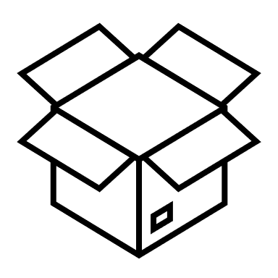
Pack the products
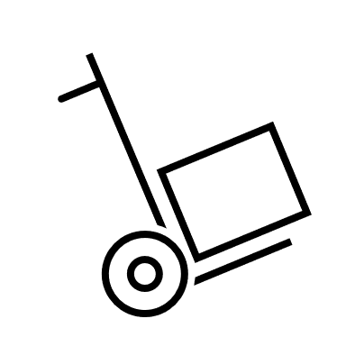
Pack your products safely and preferably in the original packaging.
Send your parcel
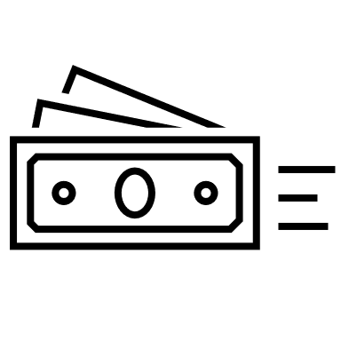
Send the package via the delivery instructions that is provided in the return-flow which can be found via the URL above.
Refund
You will receive an email from us once the return has been registered and a refund will be issued.

Insert your
logo here

